Name: **ZOHAIB HASSAN SOOMRO**

RollNo#: **19SW42**

Subject: **DBS**



1. Create a view call employee_vu based on the employee numbers, employee names and department numbers from the emp table. Change the heading for the ename to EMPLOYEE.

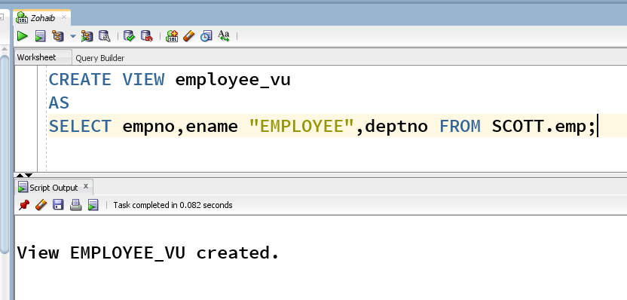

1. Display the contents of the employee_vu view.

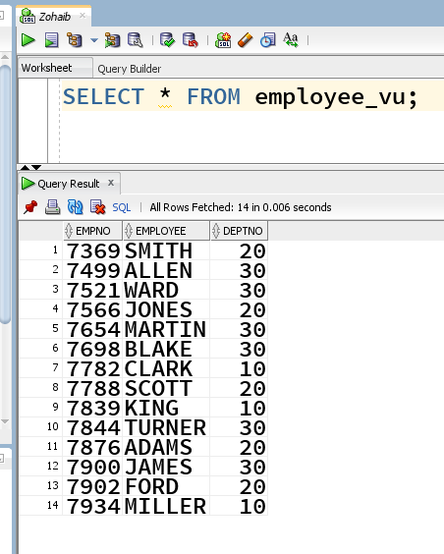

1. Create a view called SALARY_VU based on the employee names, salaries and salary grades for all employees. Use the EMP and SALGRADE tables.

1. Display the structure and contents of the DEPT50 view.

1. Test your view by reassigning “Levi Mario” (employee name) to department 80.

1. Create an index on the deptno of the Emp table. Drop the newly created index.

Index Creation:

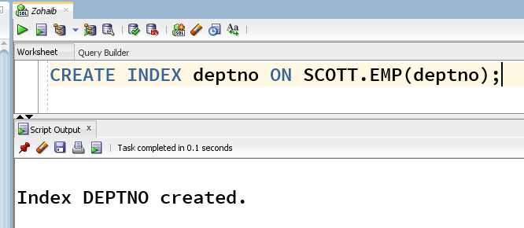

Index Deletion:

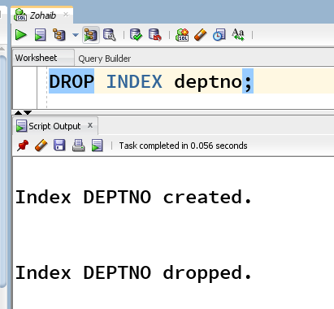

1. Create an index on the job and sal of the Emp table. Drop the newly created index.

Index Creation:

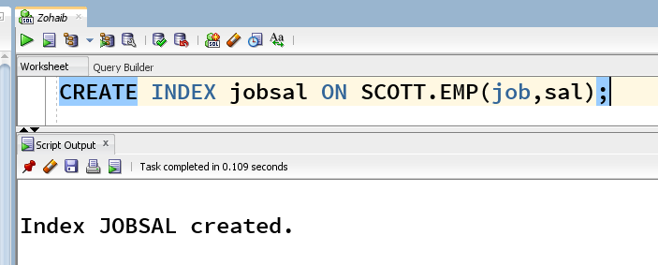

Index Deletion:

